**Session 6**

**-**

**Display devices, LCD display**

**Author:** Guillermo Cortés Orellana

**Teacher:** Tomáš Frýza



Lab assignment

1. **Preparation tasks**

* Table with LCD signals

|  |  |  |
| --- | --- | --- |
| LCD signal (s) | AVR pin(s) | Description |
| RS | PB0 | Register selection signal. Selection between Instruction register (RS=0) and Data register (RS=1) |
| R/W | GND | Pin writing/reading to/from - LCD |
| E | PB1 | Enabling pin. When this pin is set to logical low, the LCD does not care what is happening with R/W, RS, and the data bus lines. When this pin is set to logical high, the LCD is processing the incoming data |
| D[3:0] | - | We won’t use them. They would only be used if we worked in 8 bits mode |
| D[7:4] | PD4, PD5, PD6, PD7 | Four high order bidiriectional tristate data bus pins. Used for data transfer and receive between the MPU and the LCD |

* ASCII values

|  |  |  |  |
| --- | --- | --- | --- |
| Representation | Binary | Decimal | Hexadecimal |
| A | 0100 0001 | 65 | 41 |
| B | 0100 0010 | 66 | 42 |
| C | 0100 0011 | 67 | 43 |
| D | 0100 0100 | 68 | 44 |
| E | 0100 0101 | 69 | 45 |
| F | 0100 0110 | 70 | 46 |
| G | 0100 0111 | 71 | 47 |
| H | 0100 1000 | 72 | 48 |
| I | 0100 1001 | 73 | 49 |
| J | 0100 1010 | 74 | 4A |
| K | 0100 1011 | 75 | 4B |
| L | 0100 1100 | 76 | 4C |
| M | 0100 1101 | 77 | 4D |
| N | 0100 1110 | 78 | 4E |
| O | 0100 1111 | 79 | 4F |
| P | 0101 0000 | 80 | 50 |
| Q | 0101 0001 | 81 | 51 |
| R | 0101 0010 | 82 | 52 |
| S | 0101 0011 | 83 | 53 |
| T | 0101 0100 | 84 | 54 |
| U | 0101 0101 | 85 | 55 |
| V | 0101 0110 | 86 | 56 |
| W | 0101 0111 | 87 | 57 |
| X | 0101 1000 | 88 | 58 |
| Y | 0101 1001 | 89 | 59 |
| Z | 0101 1010 | 90 | 5A |

|  |  |  |  |
| --- | --- | --- | --- |
| Representation | Binary | Decimal | Hexadecimal |
| a | 0110 0001 | 97 | 61 |
| b | 0110 0010 | 98 | 62 |
| c | 0110 0011 | 99 | 63 |
| d | 0110 0100 | 10 | 64 |
| e | 0110 0101 | 101 | 65 |
| f | 0110 0110 | 102 | 66 |
| g | 0110 0111 | 103 | 67 |
| h | 0110 1000 | 104 | 68 |
| i | 0110 1001 | 105 | 69 |
| j | 0110 1010 | 106 | 6A |
| k | 0110 1011 | 107 | 6B |
| l | 0110 1100 | 108 | 6C |
| m | 0110 1101 | 109 | 6D |
| n | 0110 1110 | 110 | 6E |
| o | 0110 1111 | 111 | 6F |
| p | 0111 0000 | 112 | 70 |
| q | 0111 0001 | 113 | 71 |
| E | 0111 0010 | 114 | 72 |
| s | 0111 0011 | 115 | 73 |
| t | 0111 0100 | 116 | 74 |
| u | 0111 0101 | 117 | 75 |
| v | 0111 0110 | 118 | 76 |
| w | 0111 0111 | 119 | 77 |
| x | 0111 1000 | 120 | 78 |
| y | 0111 1001 | 121 | 79 |
| z | 0111 1010 | 122 | 7A |

|  |  |  |  |
| --- | --- | --- | --- |
| Representation | Binary | Decimal | Hexadecimal |
| 0 | 0011 0000 | 48 | 30 |
| 1 | 0011 0001 | 49 | 31 |
| 2 | 0011 0010 | 50 | 32 |
| 3 | 0011 0011 | 51 | 33 |
| 4 | 0011 0100 | 52 | 34 |
| 5 | 0011 0101 | 53 | 35 |
| 6 | 0011 0110 | 54 | 36 |
| 7 | 0011 0111 | 55 | 37 |
| 8 | 0011 1000 | 56 | 38 |
| 9 | 0011 1001 | 57 | 39 |

* Picture of time signals between ATmega328P and HD44780 (LCD keypad shield) when transmitting data **DE2**

**DE2 = 0100 0100 – 0100 0101 – 0011 0010**

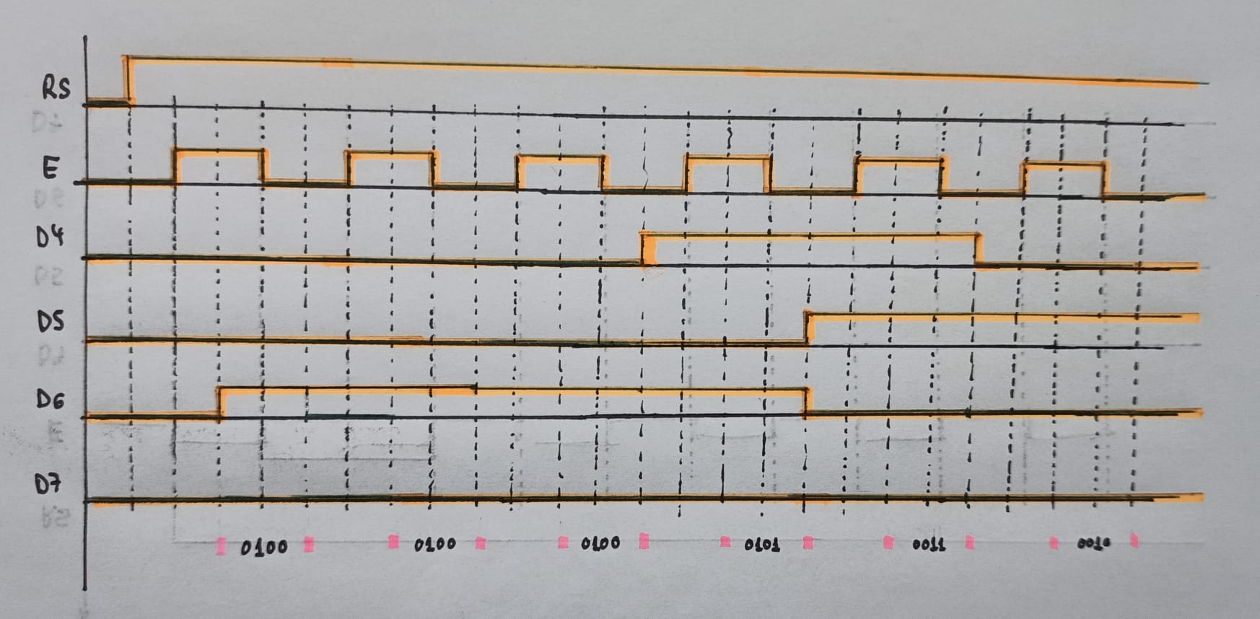

1. **Stopwatch**

* Listing of **TIMER2_OVF_vect** interrupt routine with complete stopwatch code (minutes:seconds.tenths) and square value computation

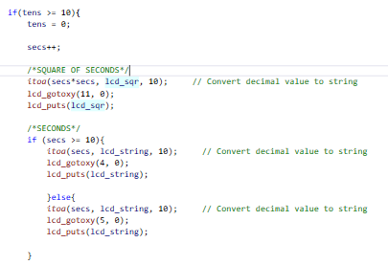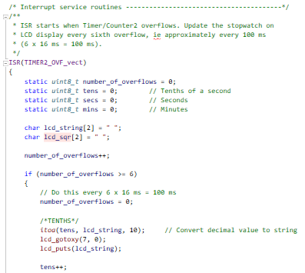

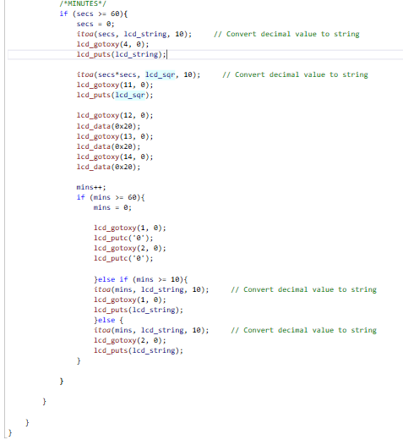

You can find the code on my GitHub:

https://github.com/GuicoRM/Digital-Electronics-2

* Screenshot of SimulIDE circuit when “Power Circuit” is applied

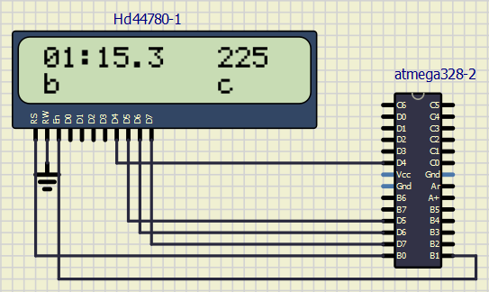

1. **Progress bar**

* Listing of **TIMER0_OVF_vect** interrupt routine with a progress bar

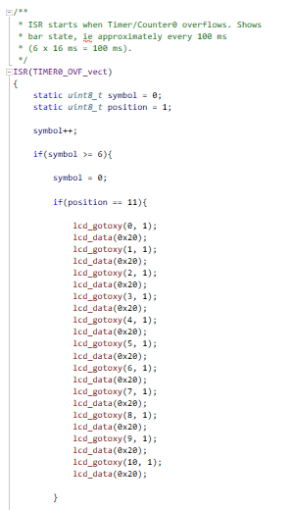

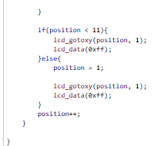.

You can find the code on my GitHub:

https://github.com/GuicoRM/Digital-Electronics-2

* Screenshit of SimulIDE circuit when ”Power Circuit” is applied

**Note:** I also added one custome character in position ‘c’ in order to test it

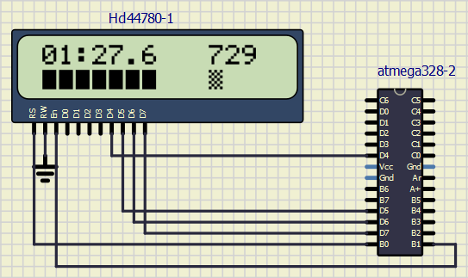

**Position ‘c’**

You can find the code of **custome** **character** on my GitHub:

https://github.com/GuicoRM/Digital-Electronics-2